Business Problem
From past few years, The Resort and City Hotel is facing high number of average cancellations. Both of them struggling with multiple issues in the result. Like, low revenues, and decrease in ideal room uses.
However, decreasing cancelation rates of both the hotels is primary goal in order to improve their profit, and also provide suggestion to enhance business success.
Analysis booking cancelations, and the factors which do not impact on business success are highlights of this report.

Assumptions:
- There is not any bad nude news circulating about hotels.
- No any recent rules/suggestions following.

Analyzing Quires:
In this project we will give the answers of the below questions:
- The variables which cause the cancellation of hotels reservation?
- The ways to decrease the cancellations of reservations?
- Suggestions regarding pricing and advertising?

Hypothesis:
- Cancellations ratio increases when price rate will be higher then competitors who provide same facilities with low rate.
- Delayed reservation responses may also cause cancelation.
- Trend of visiting clients (Are they reserve their place by walk-in through travel agents ).
Fact and Figures (Analysis):

Approximately 39% from total reservations goes towards cancellation which isn’t a good sign, and no doubt it impacts a lot on revenue. Below bar chart gives you graphical idea or ratio.

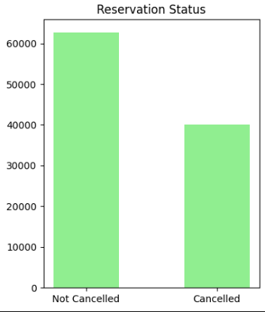

If we talk about the percentage of Resort Hotel cancellation is 30.5%, while City Hotel have 43%, and if we talk about reservation its 69.5% and 57% respectively.
On the other hand, from graph we can easily predict the number of Resort Hotel reservations i.e (counts) is lower than City Hotel which means people’s booking trend is lower than City Hotel implies Resort Hotel has high rates(expensive).
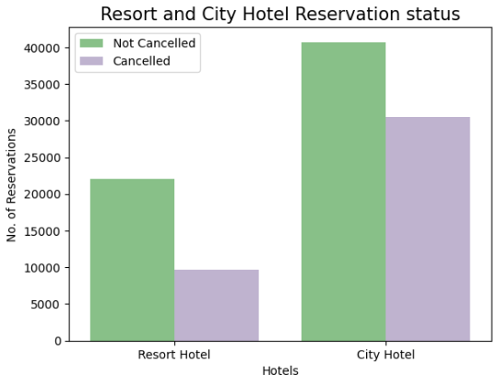

In the below chart you will see the reservation status by months. In August the number of reservations goes peak while minimum count of reservation has been seen in December and maximum reservation cancellation count is in January where minimum is in August and September.
Additionally, In the first 6 months the number of average cancellation went down after that in July the number of cancellation goes high and in the next couple of months numbers of cancellations goes down after that again random fluctuation arise.
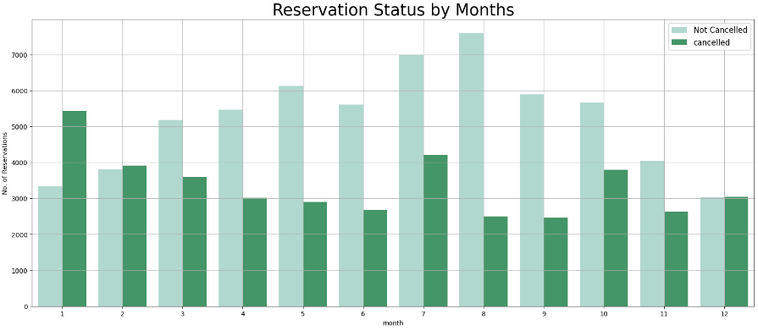From the below graph we can see that when prices get higher the number of cancellation goes up and vice versa.

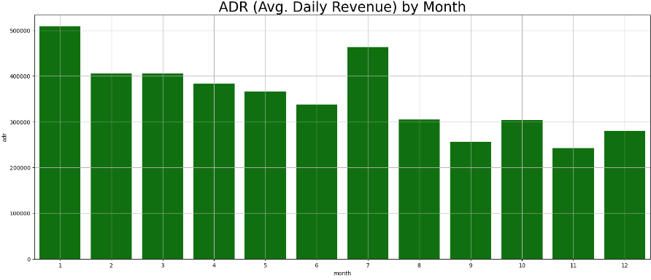
The given Pie chart shows the maximum percentage of cancellations with respect to top 12 countries.
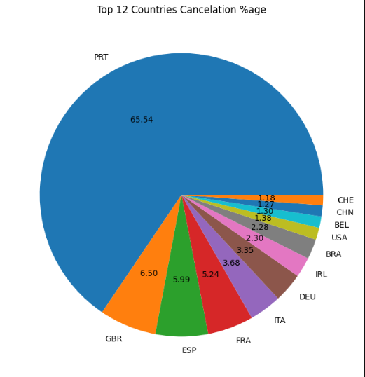

Trend of Booking:
In the below figure one can easily guess the pattern of customers booking.
Figures in percentage:
- Through online 54%
- Through offline 23%
- Through different Groups 15%
- Through walk-in 6%
- Through Corporate 1%
%age of Complementary and Aviation is below 1% .(Negligible)
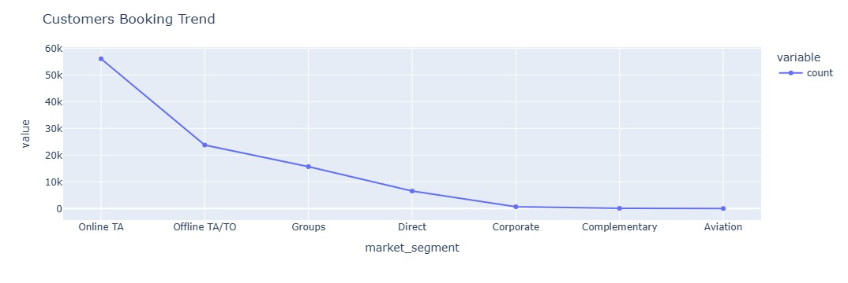

Suggestions:
- As cancellations is directly proportional to the price so we have to reconsider the current prices, specially for Resort Hotel on urgent basis.
- Make a discount plan for regular and new customers.
- Make a discount plan for advance booking.
- For the month of January the cancellation is high so we need to start campaign regarding this and offer specials discounts. (According to Economics rule “increase in your sales by decreasing your profit gives high revenue”.)
- As the Portugal has the highest number of cancelations there we need to improve the quality and hotel services as well price rates.

